36

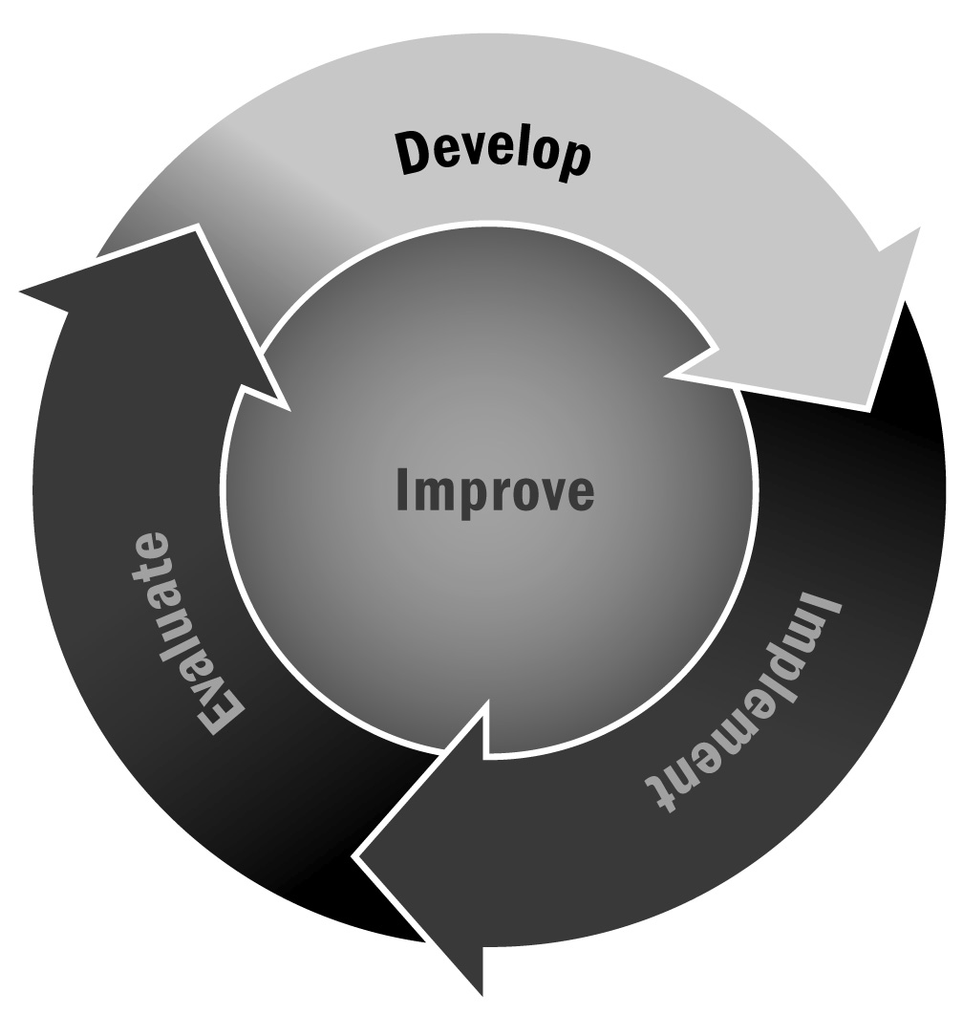
Visioning Worksheet and Meeting Agenda
In Chapter 2, you learned about the importance of creating a shared and powerful vision that can remain constant as you shape and develop your program over the next several years. A strong vision communicates to your participants, families, and community what you hope to accomplish with your afterschool and expanded learning program. Remember, when developing a vision, it is important to include families, youth representatives, volunteers, staff members, school faculty and administrators, and community organizations.
Directions: First, have individuals read the questions below and write down their initial thoughts. Next, meet as a group to identify the top priority answers to the questions and craft a vision statement out of them (a sample agenda is included on the following pages). After you have established your vision, be sure to post it prominently along with your organization’s mission.

Visioning Worksheet
Directions: Please complete the questionnaire below prior to our visioning meeting. It is important that everyone comes to the meeting ready to discuss their answers and engage in an open-minded process to turn our collective ideas into one succinct vision statement for our program.
- What is our vision of where the program will be in 5 years? 10 years?
- What does our program value?
- What are our program’s strengths?
- What is the most pressing need our program is trying to fill?
- List three words that must be in our vision statement—these should be words that represent our key values and goals for the program.

[Program Name] Visioning Meeting
Agenda
[Date] – [Time]
Meeting Goals
Include three or four goals for the meeting. Any more will feel overwhelming, and fewer may make the meeting feel unnecessary.
[Start time] | Introductions and Agenda Description  - Ask participants to introduce themselves and their role, and to share one key value and strength from their list of answers to question 2 on the visioning worksheet. When you review the agenda, invite others to suggest additional topics that they would like to discuss.
[Start time + 10 minutes] | Priority Words  - On large pieces of chart paper, write down all the keywords that people came up with. Go around the room, asking each person in turn to share their words. When a word is repeated (or a very similar word is used), place a hash mark next to it to indicate it has been selected by more than one person and note any variations of wording for the same concept (e.g., “fun” and “enjoyable” might be grouped as one). When everyone has shared their words, discuss as a group, noting which words have multiple hash marks next to them.
[Time +  10 minutes] | Key Values and Vision for the Program  - Have participants pair up to share their answers to questions 1–3 and discuss key priorities (five minutes). Ask each pair to come up with one or two key points that they agree on and share them with the large group. Note the points on chart paper and highlight when any points overlap with another pair. Open things up to the large group for discussion. Try to identify consistent themes.
[Time +  20 minutes] | Draft Vision Statements  - Back in their pairs, ask each team to draft a vision statement based on the priority words and key themes raised during the first half of the meeting. When they have a statement, ask them to write it on a piece of chart paper and post it on the wall for everyone to see.
[Time +  15 minutes) | Vote and Discuss  - Discuss as a group. Did everyone vote on the same statement? Are they very similar? Very different? What stands out?  - Next, give each person a sticker (or simply ask them to write their initials) to vote for their favorite vision statement. Allow people to write in suggested edits to their favorite statement.  - Next, discuss as a group. Can you narrow it down to two? Is there a clear favorite? Are there wording changes that might make one perfect?  - You may need to do several rounds of editing, narrowing, and voting before you can finalize the vision statement.  - If there is a great deal of division between members of the group, you may need to end the discussion and offer to create a final draft for people to vote on or approve at a later time.  - How much time you have available to spend on this meeting, your willingness to allow partners to craft your vision, and the level of agreement among the group members will dictate how this part of the meeting unfolds.
[Time +  35 minutes] | Closing and Next Steps  - Be sure to end the meeting on time and have some kind of closing activity—whether it is reviewing the final decisions that were made, talking about next steps, or simply asking everyone to reflect on the group process. Closure and reflection are important to any successful meeting.  - Be sure to use this time to confirm the time and location of the next meeting.
[End time] | Adjourn

